--WEEK 12--

CREATE OR REPLACE PROCEDURE display_hello_world IS

BEGIN

DBMS_OUTPUT.PUT_LINE('Hello World');

END;

--PART 2—

DECLARE

v_input_number NUMBER := 12345;

v_sum_of_digits NUMBER := 0;

v_num_str VARCHAR2(100);

v_digit CHAR(1);

BEGIN

-- Convert the number to a string to extract digits

v_num_str := TO_CHAR(v_input_number);

-- Loop through each character in the string

FOR i IN 1..LENGTH(v_num_str) LOOP

-- Extract each digit character

v_digit := SUBSTR(v_num_str, i, 1);

-- Convert the digit character back to a number and add it to the sum

v_sum_of_digits := v_sum_of_digits + TO_NUMBER(v_digit);

END LOOP;

-- Output the result

DBMS_OUTPUT.PUT_LINE('Sum of digits of ' || v_input_number || ' is ' || v_sum_of_digits);

END;

/ 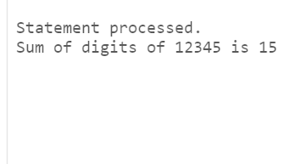

--PART3--

CREATE OR REPLACE PROCEDURE CountEvenOddNumbers (

p_numbers_array IN sys.odcinumberlist,

p_even_count OUT NUMBER,

p_odd_count OUT NUMBER

)

IS

BEGIN

-- Initialize counts

p_even_count := 0;

p_odd_count := 0;

-- Loop through each number in the array

FOR i IN 1..p_numbers_array.COUNT LOOP

-- Check if the number is even or odd

IF MOD(p_numbers_array(i), 2) = 0 THEN

p_even_count := p_even_count + 1;

ELSE

p_odd_count := p_odd_count + 1;

END IF;

END LOOP;

END;

/

DECLARE

v_numbers sys.odcinumberlist := sys.odcinumberlist(1, 2, 3, 4, 5);

v_even_count NUMBER;

v_odd_count NUMBER;

BEGIN

CountEvenOddNumbers(v_numbers, v_even_count, v_odd_count);

DBMS_OUTPUT.PUT_LINE('Number of even numbers: ' || v_even_count);

DBMS_OUTPUT.PUT_LINE('Number of odd numbers: ' || v_odd_count);

END;

/

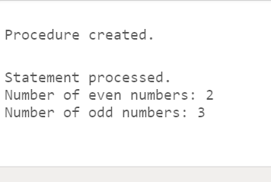

--PART 4—

CREATE OR REPLACE FUNCTION CompareAndDisplay (

p_num1 IN NUMBER,

p_num2 IN NUMBER,

p_num3 IN NUMBER

) RETURN VARCHAR2

IS

v_asc_order VARCHAR2(100);

v_desc_order VARCHAR2(100);

BEGIN

-- Find ascending order

IF p_num1 <= p_num2 AND p_num1 <= p_num3 THEN

v_asc_order := TO_CHAR(p_num1) || ', ';

IF p_num2 <= p_num3 THEN

v_asc_order := v_asc_order || TO_CHAR(p_num2) || ', ' || TO_CHAR(p_num3);

ELSE

v_asc_order := v_asc_order || TO_CHAR(p_num3) || ', ' || TO_CHAR(p_num2);

END IF;

ELSIF p_num2 <= p_num1 AND p_num2 <= p_num3 THEN

v_asc_order := TO_CHAR(p_num2) || ', ';

IF p_num1 <= p_num3 THEN

v_asc_order := v_asc_order || TO_CHAR(p_num1) || ', ' || TO_CHAR(p_num3);

ELSE

v_asc_order := v_asc_order || TO_CHAR(p_num3) || ', ' || TO_CHAR(p_num1);

END IF;

ELSE

v_asc_order := TO_CHAR(p_num3) || ', ';

IF p_num1 <= p_num2 THEN

v_asc_order := v_asc_order || TO_CHAR(p_num1) || ', ' || TO_CHAR(p_num2);

ELSE

v_asc_order := v_asc_order || TO_CHAR(p_num2) || ', ' || TO_CHAR(p_num1);

END IF;

END IF;

-- Find descending order

v_desc_order := REPLACE(REPLACE(v_asc_order, ', ', ', '), ', ', ', ');

v_desc_order := REGEXP_REPLACE(v_desc_order, '([^,]+),([^,]+),([^,]+)', '\3, \2, \1');

-- Return results

RETURN 'Ascending order: ' || v_asc_order || CHR(10) || 'Descending order: ' || v_desc_order;

END;

/

DECLARE

v_num1 NUMBER := 10;

v_num2 NUMBER := 5;

v_num3 NUMBER := 8;

v_result VARCHAR2(4000);

BEGIN

v_result := CompareAndDisplay(v_num1, v_num2, v_num3);

DBMS_OUTPUT.PUT_LINE(v_result);

END;

/

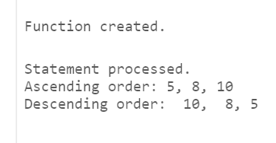

--PART5—

CREATE OR REPLACE FUNCTION perform_arithmetic(

num1 IN NUMBER,

num2 IN NUMBER,

operation IN VARCHAR2

) RETURN NUMBER IS

result NUMBER;

BEGIN

CASE operation

WHEN 'ADD' THEN

result := num1 + num2;

WHEN 'SUBTRACT' THEN

result := num1 - num2;

WHEN 'MULTIPLY' THEN

result := num1 * num2;

WHEN 'DIVIDE' THEN

IF num2 != 0 THEN

result := num1 / num2;

ELSE

RAISE_APPLICATION_ERROR(-20001, 'Cannot divide by zero');

END IF;

ELSE

RAISE_APPLICATION_ERROR(-20001, 'Invalid operation');

END CASE;

RETURN result;

END;

DECLARE

v_num1 NUMBER := 10;

v_num2 NUMBER := 5;

v_result VARCHAR2(4000);

BEGIN

v_result := PerformArithmetic(v_num1, v_num2);

DBMS_OUTPUT.PUT_LINE(v_result);

END;

/

